Getting Started with C# and .NET
  - From Java to C#.NET — A Practical Training Guide

Microsoft and its Development Platform .NET
Microsoft is a leading US technology company that develops operating systems, software, cloud services, developer tools, and consumer products worldwide.
.NET is a free, cross-platform, open-source developer platform for building many kinds of applications. It can run programs written in multiple languages, with C# being the most popular. It relies on a high-performance runtime used in production by many high-scale apps.

Overview: Microsoft Products
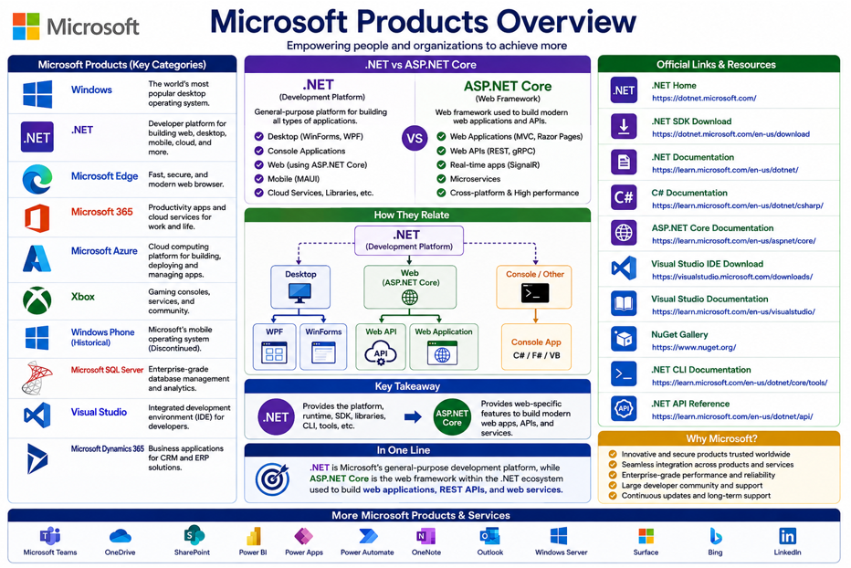

Project Types Comparison – Java, C# and others
Here is the comparison between their Projects with respect to types.
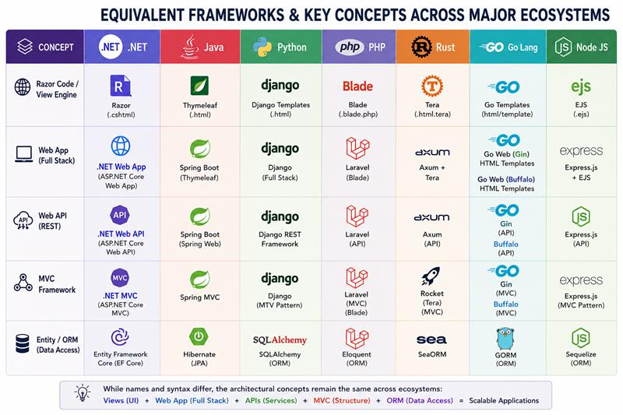

.NET & Java - Terminologies Comparison
S# | Java Term | C# Term
1 | Java | .NET / C#
2 | JDK | .NET SDK
3 | JVM | CLR
4 | JRE | .NET Runtime
5 | Javac | dotnet build / Roslyn
6 | Maven / Gradle | dotnet CLI + MSBuild
7 | pom.xml | .csproj
8 | .jar | .dll
9 | Spring Boot | ASP.NET Core
10 | Spring DI | Built-in .NET DI
11 | Hibernate / JPA | EF Core
12 | Jackson | System.Text.Json
13 | Bean Validation | Data Annotations / FluentValidation
14 | Java Annotation | C# Attribute
15 | CompletableFuture | Task / ValueTask
16 | Java Stream | LINQ
17 | Optional<T> | Nullable reference/value types / patterns
18 | ArrayList<T> | List<T>
19 | HashMap<K,V> | Dictionary<K,V>
20 | HashSet<T> | HashSet<T>
21 | Record | record
22 | Interface | Interface
23 | Abstract class | Abstract class
24 | Package | Namespace
25 | Maven package | NuGet package

Useful Learning Links for .NET
They are as under:
- Microsoft Home Page: https://www.microsoft.com/en-pk
- Microsoft Windows: https://www.microsoft.com/en-us/windows/
- .NET Web, Mobile, Cloud, AI and ML: https://dotnet.microsoft.com/en-us/
- .NET SDK Download: https://dotnet.microsoft.com/en-us/download
- Install .NET/VS on Windows: https://learn.microsoft.com/en-us/dotnet/core/install/windows
- Visual Studio Development IDE Download: https://visualstudio.microsoft.com/downloads/
- Visual Studio Development IDE Documentation: https://learn.microsoft.com/en-us/visualstudio/
- Introduction to .NET: https://learn.microsoft.com/en-us/dotnet/core/introduction
- ASP.NET Core - App Types, Security and Identity, Test, Host and Deploy, Video Tutorials: https://learn.microsoft.com/en-us/aspnet/core/
- ASP.NET Core – Web UI: https://learn.microsoft.com/en-us/aspnet/core/tutorials/choose-web-ui
- C# - Tutorial: https://learn.microsoft.com/en-us/dotnet/csharp/
- C#15 with .NET 11: https://learn.microsoft.com/en-us/dotnet/csharp/whats-new/csharp-15
- Statements: https://learn.microsoft.com/en-us/dotnet/csharp/programming-guide/statements-expressions-operators/statements
- .NET supports 5 categories of types (Classes, Structures, Enumerations, Interfaces, Delegates): https://learn.microsoft.com/en-us/dotnet/standard/base-types/common-type-system
- Classes and Structs: https://learn.microsoft.com/en-us/dotnet/csharp/programming-guide/classes-and-structs/methods
- Collections and Data Structures: https://learn.microsoft.com/en-us/dotnet/standard/collections/
- Generic Collections: https://learn.microsoft.com/en-us/dotnet/standard/generics/collections
- Interfaces: https://learn.microsoft.com/en-us/dotnet/standard/generics/interfaces
- General structure of a C# program: https://learn.microsoft.com/en-us/dotnet/csharp/fundamentals/program-structure/
- Microsoft Azure cloud platform: https://azure.microsoft.com
- Official .NET open-source repositories: https://github.com/dotnet
- NuGet Gallery to Install .NET Packages: https://www.nuget.org/
Some useful Links by Microsoft for Java and Python Developers who want to learn .NET:
- .NET > Java: https://learn.microsoft.com/en-us/dotnet/csharp/tour-of-csharp/tips-for-java-developers
- .NET > Python: https://learn.microsoft.com/en-us/dotnet/csharp/tour-of-csharp/tips-for-python-developers
Since 2007 following site covers almost all aspects of .NET Apps Development with Code, Slides and YouTube:
- Learn .NET History: https://csharp-video-tutorials.blogspot.com/p/free-dot-net-video-tutorials-for.html
- IR Code Snippets Book for Java: In Docs folder
- Free Programming PDF Books Collection at Goal Kicker.com: https://books.goalkicker.com/
- C# 15: https://www.damirscorner.com/blog/posts/20260821-UnionTypesInCs15.html?via=dailydev
- Daily Dev for Development Updates: https://daily.dev
Java Learning Tutorial:
- Java Tutorial Home Page: https://docs.oracle.com/javase/tutorial/
- OOPs Concepts:https://docs.oracle.com/javase/tutorial/java/concepts/index.html
- Classes and Objects: https://docs.oracle.com/javase/tutorial/java/javaOO/index.html
- Package Manager: https://maven.apache.org/
Today, prompting AI models and mastering 'vibe coding' has become essential for learning multiple languages. We must build fluency in prompt writing using AI tools, such as:
- OpenAI – ChatGPT, Google – Gemini, Anthropic – Claude,
- Meta – Llama, DeepSeek, Cursor and so on
One Compiler – Online Code Testing Environment
- https://onecompiler.com/
- https://microsoftlearning.github.io/c-sharp-minor/
.NET Commands – .NET Projects quick Compile, Run and Publish using Windows Command Prompt:
Whole Solution BUILD/RUN Command
  - dotnet build UserManagementApi.sln
  - dotnet run UserManagementApi.sln
Publish as self-contained application – include .NET Runtime
  - dotnet publish UserManagementApi.sln -c Release --self-contained true
Individual Project RUN Command
  - dotnet run

Unit Test Solution Build and Test
  - dotnet build Translation_UnitTests.csproj -c Release
  - dotnet test Translation_UnitTests.csproj -c Release --no-build --no-restore

Software to Install - Prerequisites
- Visual Studio 2026 - Community Edition (Professional and Enterprise editions requires Product Key)
  - https://visualstudio.microsoft.com/downloads/

- .NET SDK 10 (coming up next .NET 11 in Nov 2026)
  - https://dotnet.microsoft.com/en-us/download/dotnet/10.0

- .NET Runtime 10 (auto Installed with Visual Studio Setup above)

- DBeaver Client Software for SQLite database connectivity
  - https://dbeaver.io/download/

- Windows Command Prompt or Powershell

- Git (for repo access: pull/push)
  - https://git-scm.com/install/windows

GIT Commands
They are as under:
GIT Commands - echo "# CSharp Training Session Solutions" >> README.md
git init
git add .
git commit -m "first commit"
git branch -M main
git remote add origin https://github.com/inayat68/CSharpTrainingSessionSolutions.git
git push -u origin main
git pull origin main

How .NET evolved gradually?
Some key points are as under:
- 1981: Microsoft provided MS-DOS for the IBM PC, which became one of the most widely used PC operating systems.
- 1985: Microsoft launched Windows 1.0, introducing a graphical user interface that ran on top of MS-DOS.
- 1990: Windows 3.0 became highly successful and significantly expanded Microsoft's presence in the desktop operating-system market.
- 1991: Microsoft launched the first version of Visual Basic (VB), making Windows application development easier and more accessible.
- 1995: Windows 95 introduced a major redesign and popularized features such as the Start menu, taskbar, and improved Plug and Play support.
- 1996: Classic ASP Server-side scripting technology for dynamic web pages extension *.asp
- 1997: VBScript Common scripting language used with Classic ASP
- 1998: Windows 98 continued the Windows 9x line with improved hardware and Internet integration.
- 1998-2001: Visual Basic 6.0 (VB6) last version was released and became widely used for Windows desktop and business applications. VB6 Era: Developers commonly used COM/ActiveX, ADO, and Windows APIs for application development and database connectivity.
- 2002: Microsoft introduced .NET Framework 1.0, initially focused on Windows application and web development.
- 2016: Microsoft introduced .NET Core, a redesigned, open-source and cross-platform implementation of .NET.
- 2002–2019: The .NET Framework evolved through versions such as 2.0, 3.5, 4,0, 4.5, 4,6, 4.7 and became widely used for Windows, ASP.NET, and enterprise applications. .NET Framework 4.8 was released on April 18, 2019.
- 2014: Microsoft announced the open-sourcing of the .NET Core runtime and framework libraries on November 12, 2014, and placed the project under the .NET Foundation.
- 2020: .NET 5 unified .NET Core and other .NET technologies under the single “.NET” name.
- Today: Modern .NET is open-source, cross-platform, high-performance, and maintained by Microsoft and the .NET community.
- C# is the primary programming language for .NET, with F# and Visual Basic also supported. Currently in use, latest C# version is 14.
- .NET can be used to build Web APIs, web applications, desktop applications, cloud services, console applications, and more.
- The .NET SDK provides the tools required to create, build, test, and publish .NET applications.
- The .NET Runtime / CLR provides the environment required to execute .NET applications, including JIT compilation of IL into native code.
- NuGet is the package manager for .NET, while Visual Studio and Visual Studio Code are commonly
- .NET LTS (Long-Term Support): A .NET version supported by Microsoft for a longer period, making it the preferred choice for production and enterprise applications. .NET 6, 8, and currently 10 are LTS
- .NET STS (Standard-Term Support): A .NET version supported for a shorter period, mainly for getting newer features sooner. Previously .NET 7, 9, and upcoming .NET 11 (in Nov 2026) are STS.

Java evolved Stages
Some key points are as under:
- 1991 Project Oak: Java began at Sun Microsystems as Oak, developed by the Green Team led by James Gosling and his team, initially targeting consumer electronic devices.
- 1995 Java 1.0 announced: Sun officially announced Java and introduced the “Write Once, Run Anywhere” concept. Oak was renamed Java because the name “Oak” was already trademarked.
- 1996 JDK 1.0: First official Java Development Kit released.
- 1997 JDK 1.1: Inner classes, JDBC, RMI, JavaBeans and other major features introduced.
- 1998 Java 2 / J2SE 1.2: Java 2 platform introduced with major improvements and the Swing GUI toolkit.
- 2000 J2SE 1.3: Performance improvements and features such as HotSpot JVM integration.
- 2002 J2SE 1.4: Assertions, regular expressions, NIO, logging and other important APIs added.
- 2004 Java 5 / J2SE 5.0: Major language update: Generics, Annotations, Enums, Autoboxing, Enhanced for-loop, Varargs.
- 2006 Java 6: Platform renamed from J2SE to Java SE; performance and library improvements.
- 2010 Oracle acquired Sun Microsystems and became the primary steward of Java.
- 2011 Java 7: Try-with-resources, diamond operator, strings in switch, multi-catch and other features.
- 2014 Java 8: Major milestone: Lambda expressions, Stream API, functional interfaces, default methods.
- 2017 Java 9: Java Platform Module System (JPMS) introduced; 6-month release cycle began.
- 2018 Java 10 / 11: Local variable type inference (var); Java 11 became an LTS release.
- 2021 Java 17: Major LTS release with sealed classes and other language/platform improvements.
- 2023 Java 21: Major LTS release; virtual threads, record patterns, pattern matching improvements and more.
- 2024 Java 22: Continued language, JVM and API evolution.
- 2025 Java 24 / Java 25: Continued six-month release cycle; Java 25 became an LTS release.

Microsoft VB6 & ASP Classic b/w 1991-2001 Era
Showing Report Form - View and Code screenshot
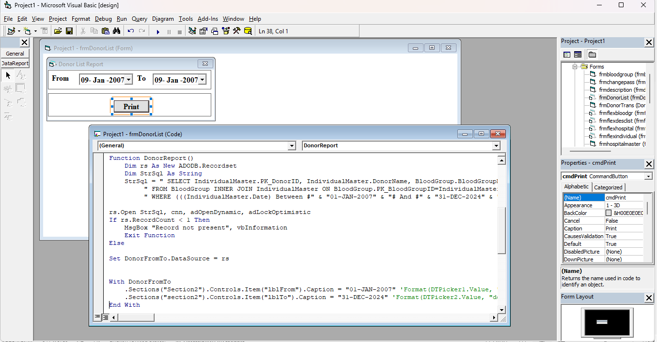
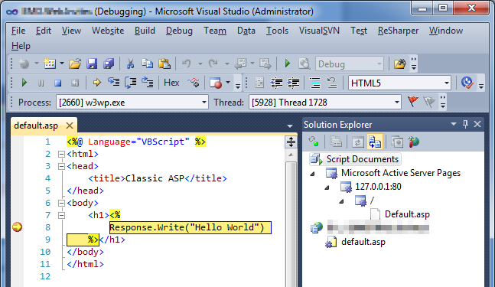

.NET Solution File – Extension/Format

Older .SLN | LATEST .SLNX
MyApp.sln | MyApp.slnx
Older solution format | New XML solution forma
Text-based | XML-based
More verbose | Much simpler
Still supported | Newer/recommended format

.NET App/Project Types with Commands
S# | Project Types | Description
1 | # Create Directory/Folder  - mkdir TrainingApp  - md TrainingApp | Creates a new directory/folder named TrainingApp.  Md is same as mkdir command
2 | # Create a .NET solution file  dotnet new sln -n MyDotNetApp --format sln | Creates a .NET Solution file (.sln / .slnx) named MyDotNetApp to organize and manage multiple projects.
3 | # Add project to solution  dotnet sln MyDotNetApp.sln add MyConsoleApp/MyConsoleApp.csproj | Adds the specified project (.csproj) to the existing solution.
4 | # Console App  dotnet new console -n MyConsoleApp | Build command-line applications that run in a terminal or console window. Useful for utilities, automation, background processes, and learning C#.
5 | # .NET Core App  dotnet new web -n MyWebApp | Create reusable .NET code libraries containing classes, methods, and other functionality that can be shared across multiple applications.
6 | # HTTP API apps  dotnet new webapi -n MyWebApp | Develop HTTP-based services with ASP.NET Core that expose data and functionality through APIs, commonly using REST and JSON.
7 | # Page-focused web UI with MVC  dotnet new mvc -n MyMvcApp | Develop web applications using the Model-View-Controller (MVC) design pattern, separating application data, UI, and request-handling logic.
8 | # Page-focused web UI with Razor Pages  dotnet new webapp -n MyRazorApp | Develop page-focused web applications with a clean separation of concerns, where each Razor Page handles a specific page and its associated logic.
9 | # Real-time web apps with SignalR  dotnet new web -n MySignalRApp | Add real-time functionality to web applications, allowing the server to instantly push updates to connected clients without requiring client to repeatedly request new data.
10 | # Data-driven web apps  dotnet new webapp -n MyDataApp | Create data-driven web applications with ASP.NET Core that connect to databases and display, manage, and process application data.
11 | # Interactive client-side Blazor apps  dotnet new blazorwasm -n MyBlazorApp | Build interactive web UIs with reusable Blazor components, running client-side through WebAssembly and enabling rich, app-like browser experiences.
12 | Whole Solution BUILD/RUN Command  - dotnet build UserManagementApi.sln  dotnet run UserManagementApi.sln | Whole Solution build which will build each project
13 | Publish with NuGet Packages  dotnet publish App.csproj -c Release -r win-x64 --self-contained true --source https://api.nuget.org/v3/index.json | Publish with NuGet Packages

Understanding .NET & ASP.NET Terminologies
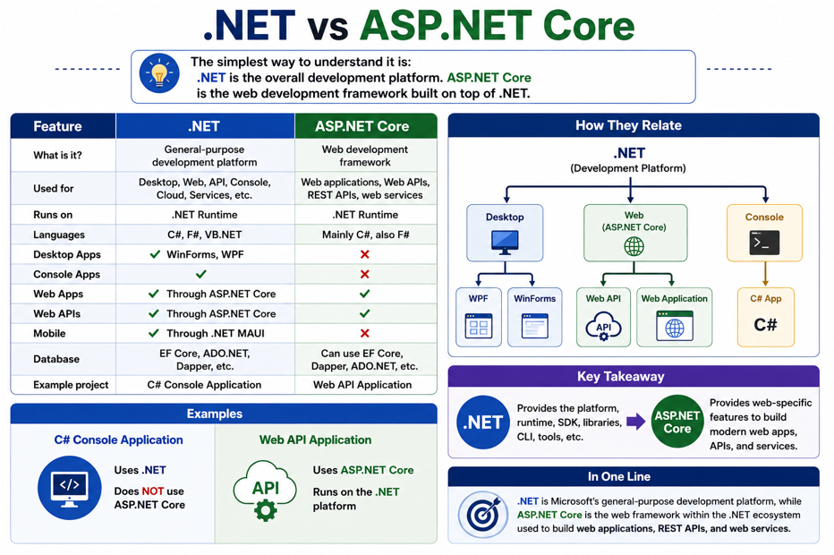

.NET SDK vs .NET Runtime
Here is the diagram illustration for demo purpose:
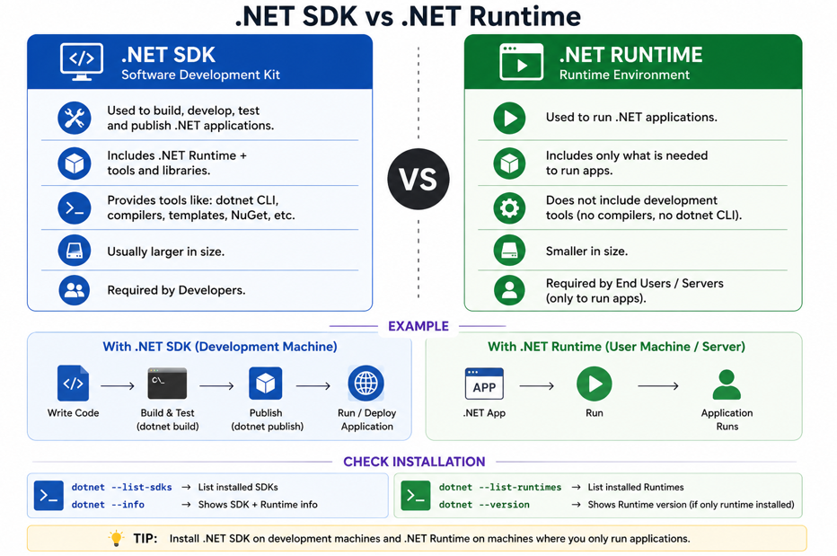

How .NET Application Runs? JIT and CLR
Here is the diagram illustration for demo purpose:
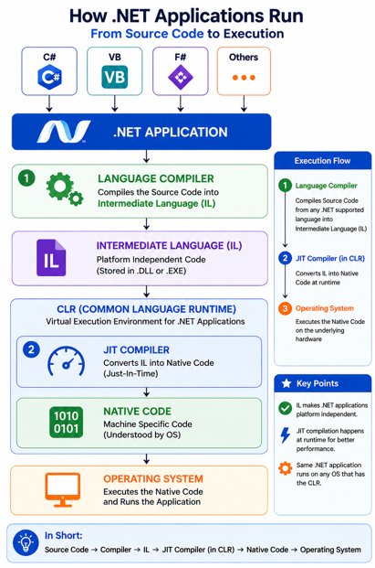

How Java Application Runs? JVM
Here is the diagram illustration for demo purpose

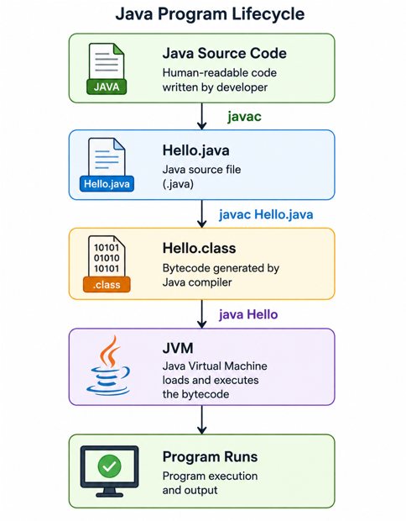

.NET versions check with Environment Variables
Here is the diagram illustration for demo purpose:
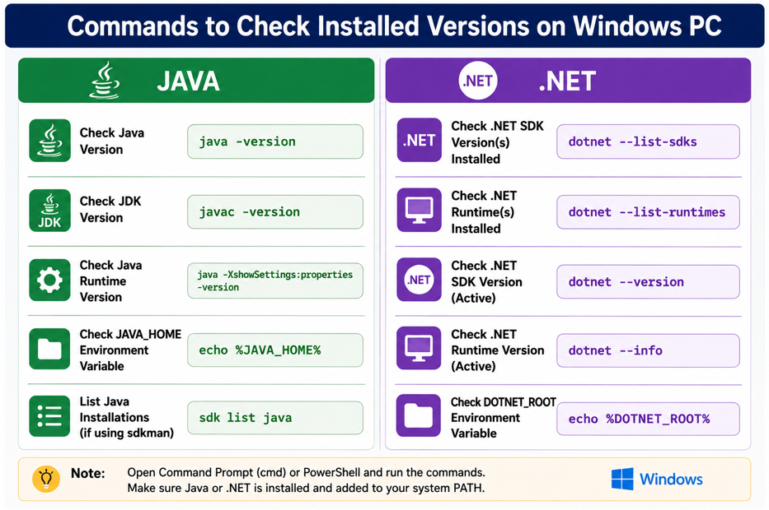
Java | C#
- java -version | - dotnet –info  - dotnet –version
- javac -version | - dotnet --list-sdks  - dotnet --list-runtimes
- where java
- Find Java installation path
- where javac  - Find JDK installation path | - where dotnet
- echo %JAVA_HOME%  - setx JAVA_HOME "C:\Program Files\Java\jdk-21" | - echo %DOTNET_ROOT%  - setx DOTNET_ROOT "C:\Program Files\dotnet"
- $env:JAVA_HOME  - $env:JAVA_HOME = "C:\Program Files\Java\jdk-21" | - $env:DOTNET_ROOT  - $env:DOTNET_ROOT = "C:\Program Files\dotnet"

.NET Commands – For Project and Packages
Here is the list of commands for Project and Packages manipulation:

S.No. | Project and Package Commands
1 | # Create a new project directory | # Add/Remove Pkg (--version 13.0.3)
 | mkdir MyDotNetApp | dotnet add/remove package Newtonsoft.Json
 |  | # List NuGet packages used by project
2 | # Change to the project directory | dotnet list package
 | cd MyDotNetApp | # List available project templates
 |  | dotnet new list
3 | # Create a .NET solution file | # List installed .NET tools
 | dotnet new sln -n MyDotNetApp --format sln | dotnet tool list –global
 |  | # Search available templates
4 | # Create a Console application | dotnet new search webapi
 | dotnet new console -n MyConsoleApp | # Install a .NET tool
 |  | dotnet tool install --global dotnet-ef
5 | # Add the Console project to the solution | # Update a .NET tool
 | dotnet sln MyDotNetApp.sln add MyConsoleApp/MyConsoleApp.csproj | dotnet tool update --global dotnet-ef
 |  | # Add/Remove project reference
6 | # Build the solution | dotnet add/remove reference ../MyLibrary/MyLibrary.csproj
 | dotnet build | # Publish self-contained application
 |  | dotnet publish -c Release --self-contained true
7 | # Run the Console application | # Publish for a specific runtime
 | dotnet run --project MyConsoleApp | dotnet publish -c Release -r win-x64 --self-contained true
8 | # Run commands to clean/test/publish project | #To remove the blockage install pkg
 | dotnet clean / test / publish | dotnet nuget disable source mlogica

C# Project - Creations Commands
# General syntax for creating a .NET project | # ASP.NET Core Razor Pages Web Application
dotnet new <template> -n <ProjectName> | dotnet new webapp -n MyRazorApp
# ASP.NET Core Web API — Minimal API | # Razor Pages — webapp alias
dotnet new webapi -n MyWebApi | dotnet new razor -n MyRazorApp
# ASP.NET Core Web API — Controllers | # Blazor Web App
dotnet new webapi -n MyWebApi --use-controllers | dotnet new blazor -n MyBlazorApp
# ASP.NET Core MVC Web Application | # Blazor WebAssembly
dotnet new mvc -n MyMvcApp | dotnet new blazorwasm -n MyBlazorApp
# xUnit Test Project | # gRPC Service
dotnet new xunit -n MyTests | dotnet new grpc -n MyGrpcService
# MSTest Project | # Worker Service
dotnet new mstest -n MyTests | dotnet new worker -n MyWorkerService
# NUnit Test Project | # Windows Forms Application
dotnet new nunit -n MyTests | dotnet new winforms -n MyWinFormsApp
# Class Library | # WPF Application
dotnet new classlib -n MyLibrary | dotnet new wpf -n MyWpfApp
# ASP.NET Core Empty Web Application | # Razor Class Library
dotnet new web -n MyWebApp | dotnet new razorclasslib -n MyRazorLibrary
devenv MySolution.sln | dotnet build MySolution.sln

Visual Studio IDE – How to Open?
Here is the diagram illustration for demo purpose:
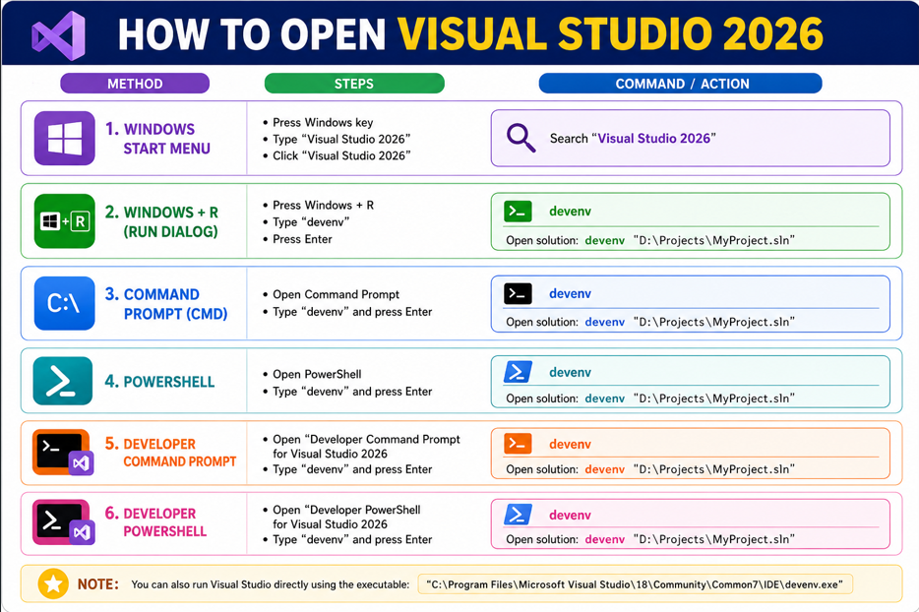

Short Keys IntelliJ Idea and Visual Studio
Here is the diagram illustration for demo purpose:
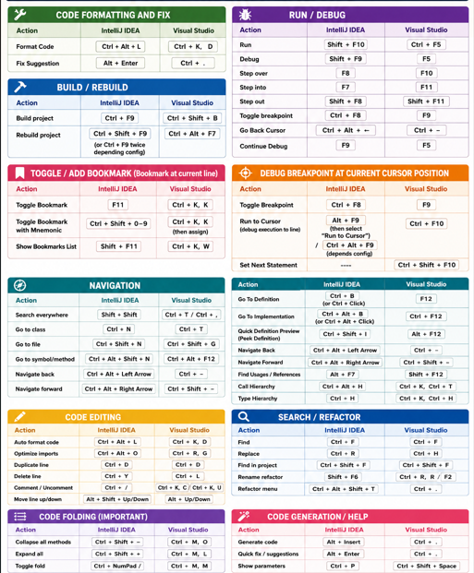

Root Namespace
Here is the diagram illustration for demo purpose:
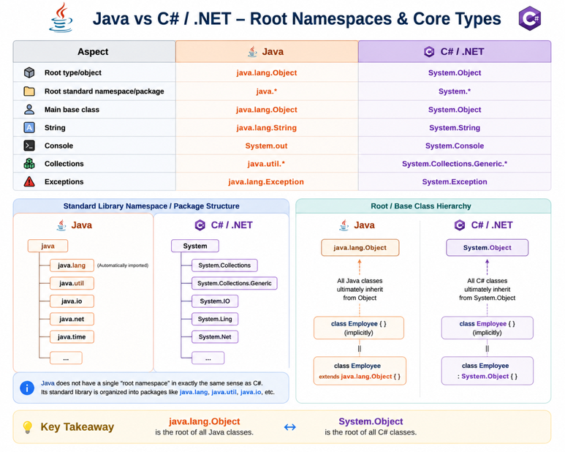

Visual Studio – IntelliSense with Description
While typing a function name, the IntelliSense will show the description.
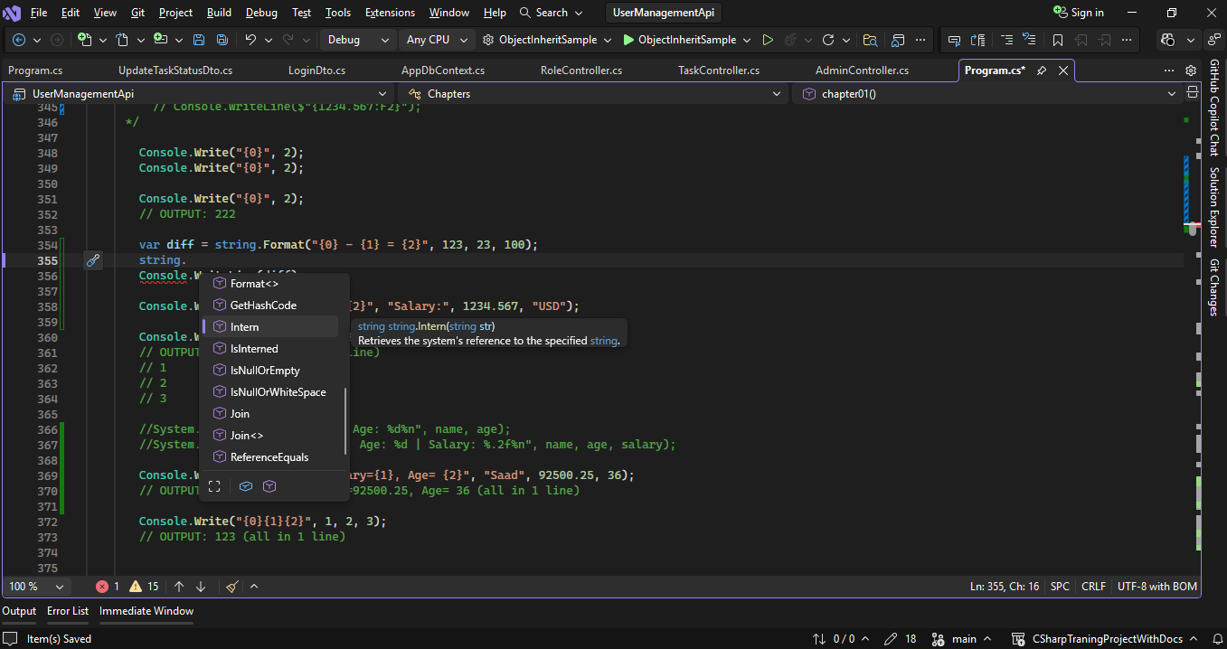

C# Classes Types & Accessibility is same as Java
While typing a function name, the IntelliSense will show the description
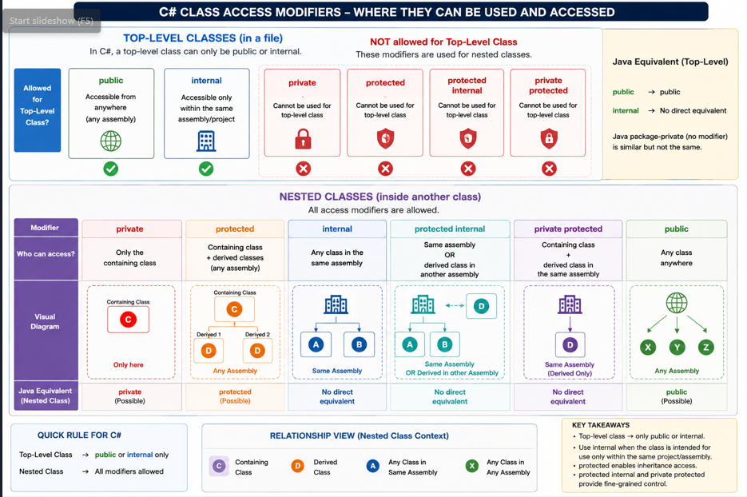

Java vs C# - Similarities & Differences
Refer to separate Document / PDF.

Visual Studio - Web API Options
Option | Checked/Unchecked | Means
Framework | .NET 10.0 (Long Term Support) | Selects the .NET version that your Web API will target. .NET 10 LTS is a long-term supported version.
Authentication type | None | No authentication mechanism is automatically configured. You can add JWT, Identity, OAuth, etc. later.
Configure for HTTPS | ☑ Checked | Configures the project to run using HTTPS, providing encrypted communication between client and API. Recommended.
Enable container support | ☐ Unchecked | Does not add Docker/container support to the project. Check this if you plan to run the API inside a Docker/container.
Container OS | Linux | Appears when container support is enabled. Specifies the operating system for the container. Linux is commonly used for .NET containers.
Container build type | Dockerfile | Specifies how the container image will be built. A Dockerfile contains the instructions for building the application image.
Enable OpenAPI support | ☑ Checked | Adds OpenAPI/Swagger support, allowing you to describe, document, and test your API endpoints through Swagger UI. Recommended for development.
Do not use top-level statements | ☑ Checked | Creates the traditional Program structure with an explicit Program class and Main() method instead of using C# top-level statements. Useful for Java developers because it looks more familiar.
Use controllers | ☑ Checked | Creates the API using Controller classes, e.g. ProductsController : ControllerBase. This is the traditional and structured ASP.NET Core Web API approach.
Enlist in Aspire orchestration | ☐ Unchecked | Adds the project to .NET Aspire orchestration, which is useful for managing distributed applications consisting of multiple services, databases, messaging systems, etc.
Aspire version | 13.2 | Specifies the .NET Aspire version when Aspire orchestration is enabled.

Visual Studio – Extension Files
Extension | Stands for / Purpose | Contains / Usually Commit to Git?
.sln/.slnx | Solution file | References one or more projects (.csproj) and solution-level configuration (YES)
.csproj | C# Project file | Project name, target framework, NuGet packages, project references, build settings, etc. (YES)
.csproj.user | C# Project User Settings | Developer/machine-specific Visual Studio settings such as debugging and launch preferences (NO)

HTTP Verbs - ASP.NET Core Action Attributes
Attribute | HTTP Method | Purpose
[HttpGet] | GET | Retrieve/read data from the server. Get a list of products
[HttpPost] | POST | Create/add new data on the server. Create a new product
[HttpPut] | PUT | Update/replace an existing resource. Update a product
[HttpPatch] | PATCH | Partially update an existing resource. Change only the product price
[HttpDelete] | DELETE | Delete/remove a resource. Delete a product

.NET and C# Brief Ecosystem
Here is the diagram illustration for demo purpose:
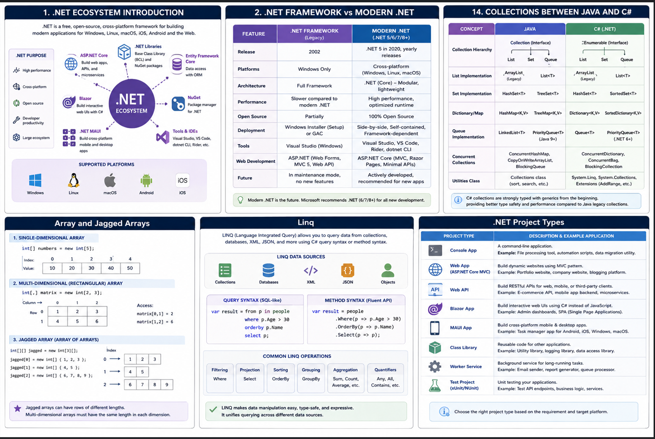

C# Code Typing Shortcuts in Visual Studio
Here is the diagram illustration for demo purpose:

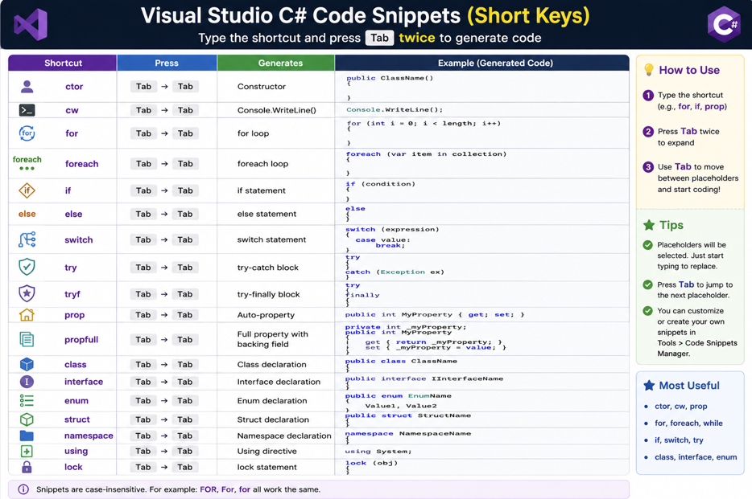

Java Ecosystem
Here is the diagram illustration for demo purpose:
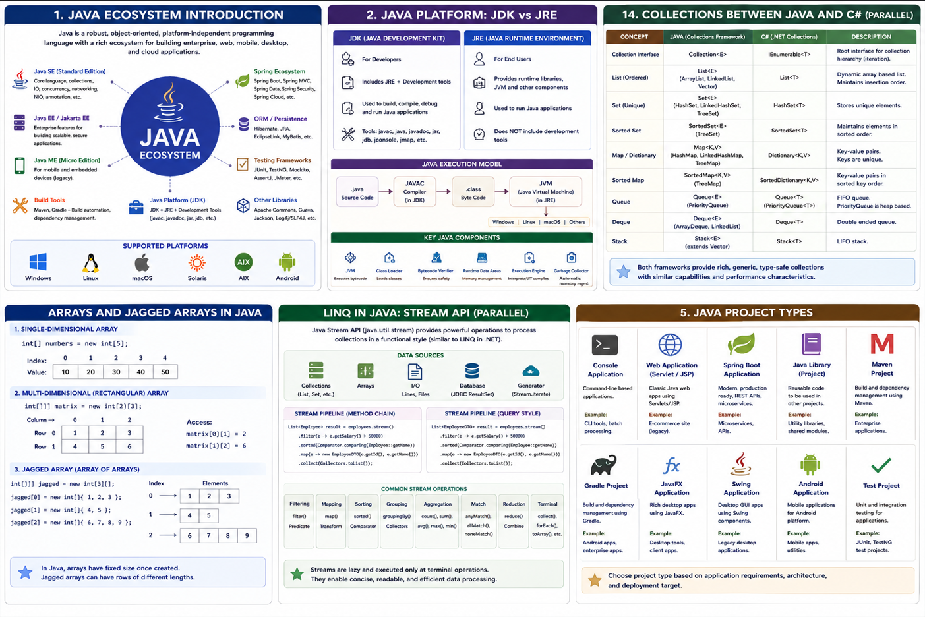

Java vs C# - High Level Code Comparison
Here is the diagram illustration for demo purpose:
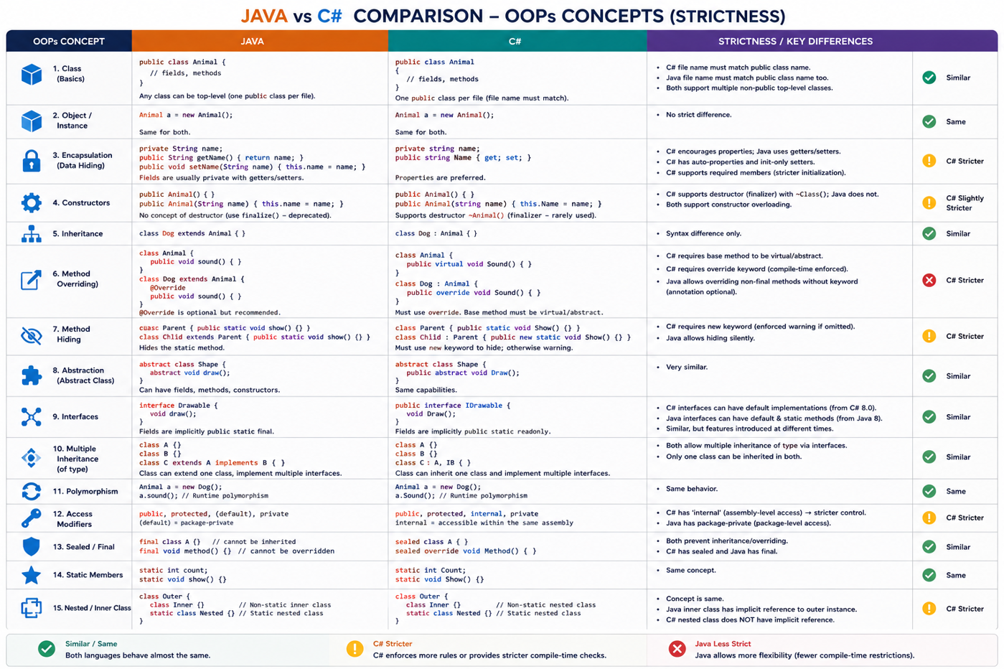

NuGet Package to Install in .NET Project
After searching a package command is shown to install it.
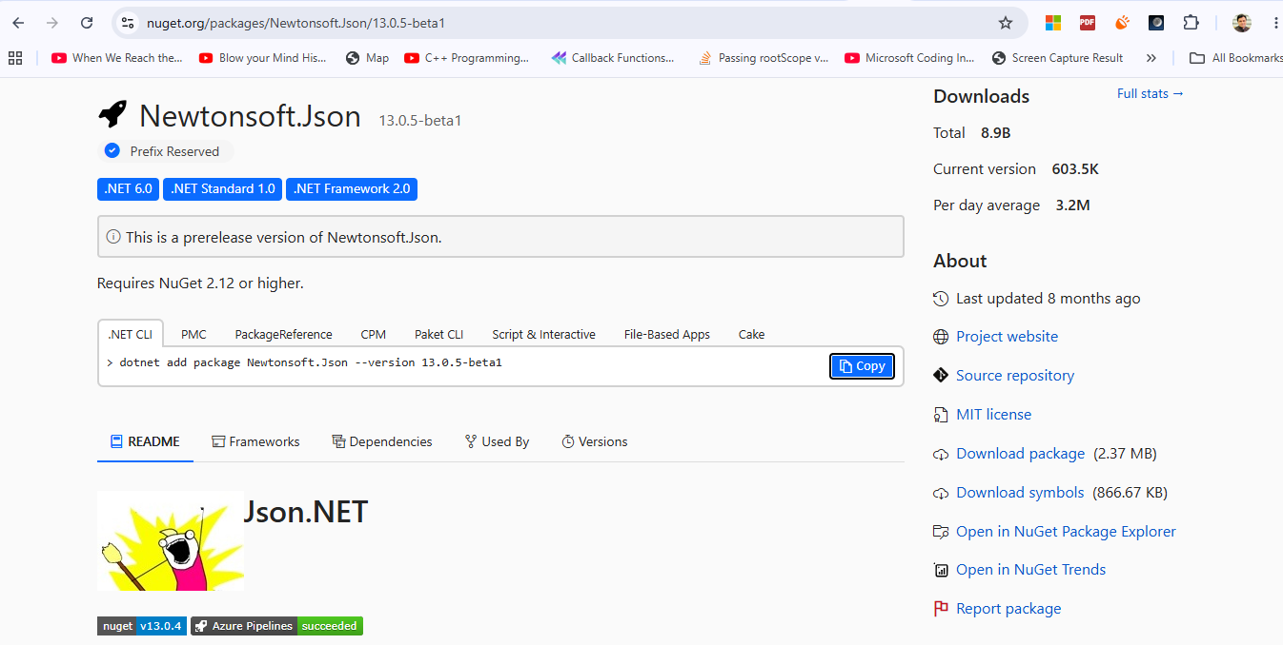

JWT Auth App - DB Schema used in .NET Project
Here is the diagram illustration for demo purpose:
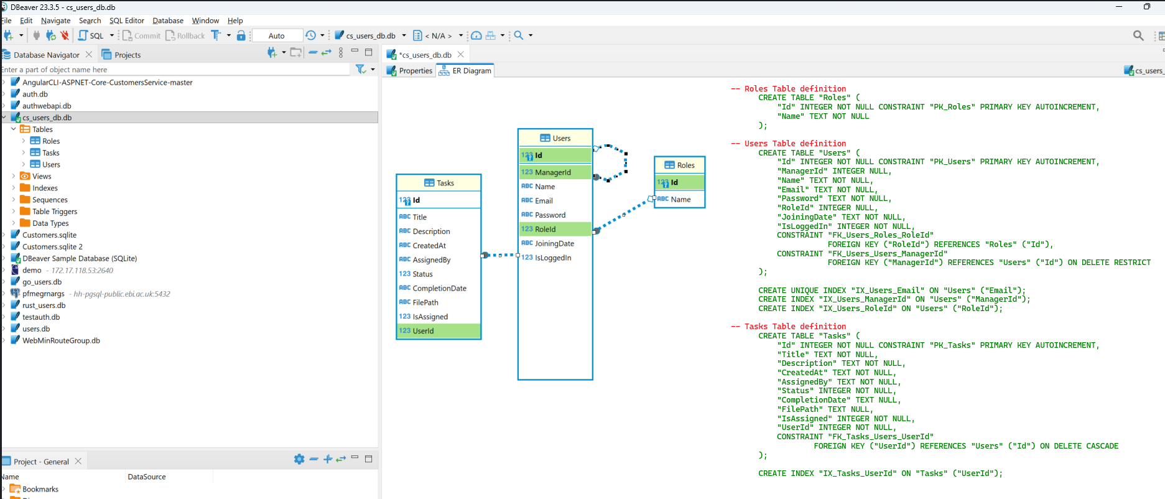

OLLAMA Runtime Platform for AI Models implementation using .NET Project
Here is the diagram illustration for demo purpose:

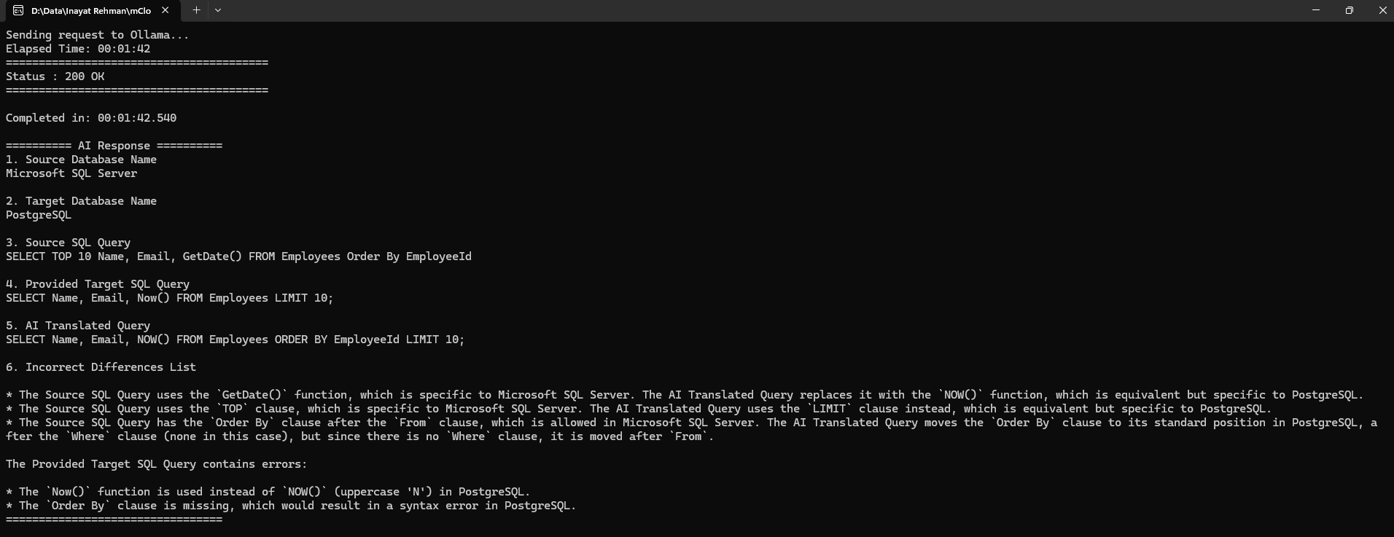

Customer-Order MVC App – Home Page
Home Page:
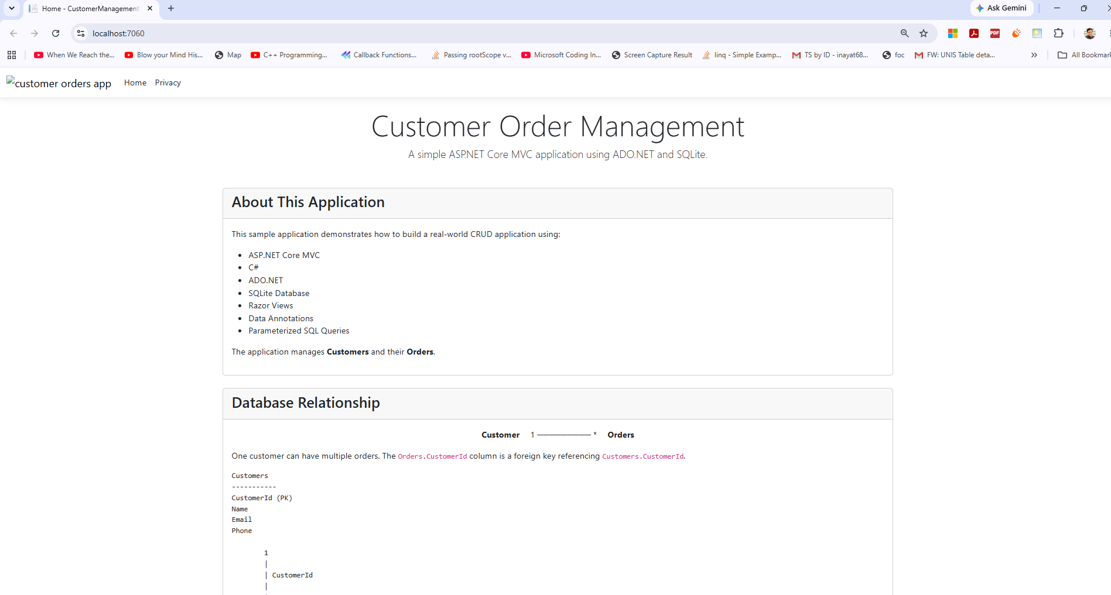
Customer Page:
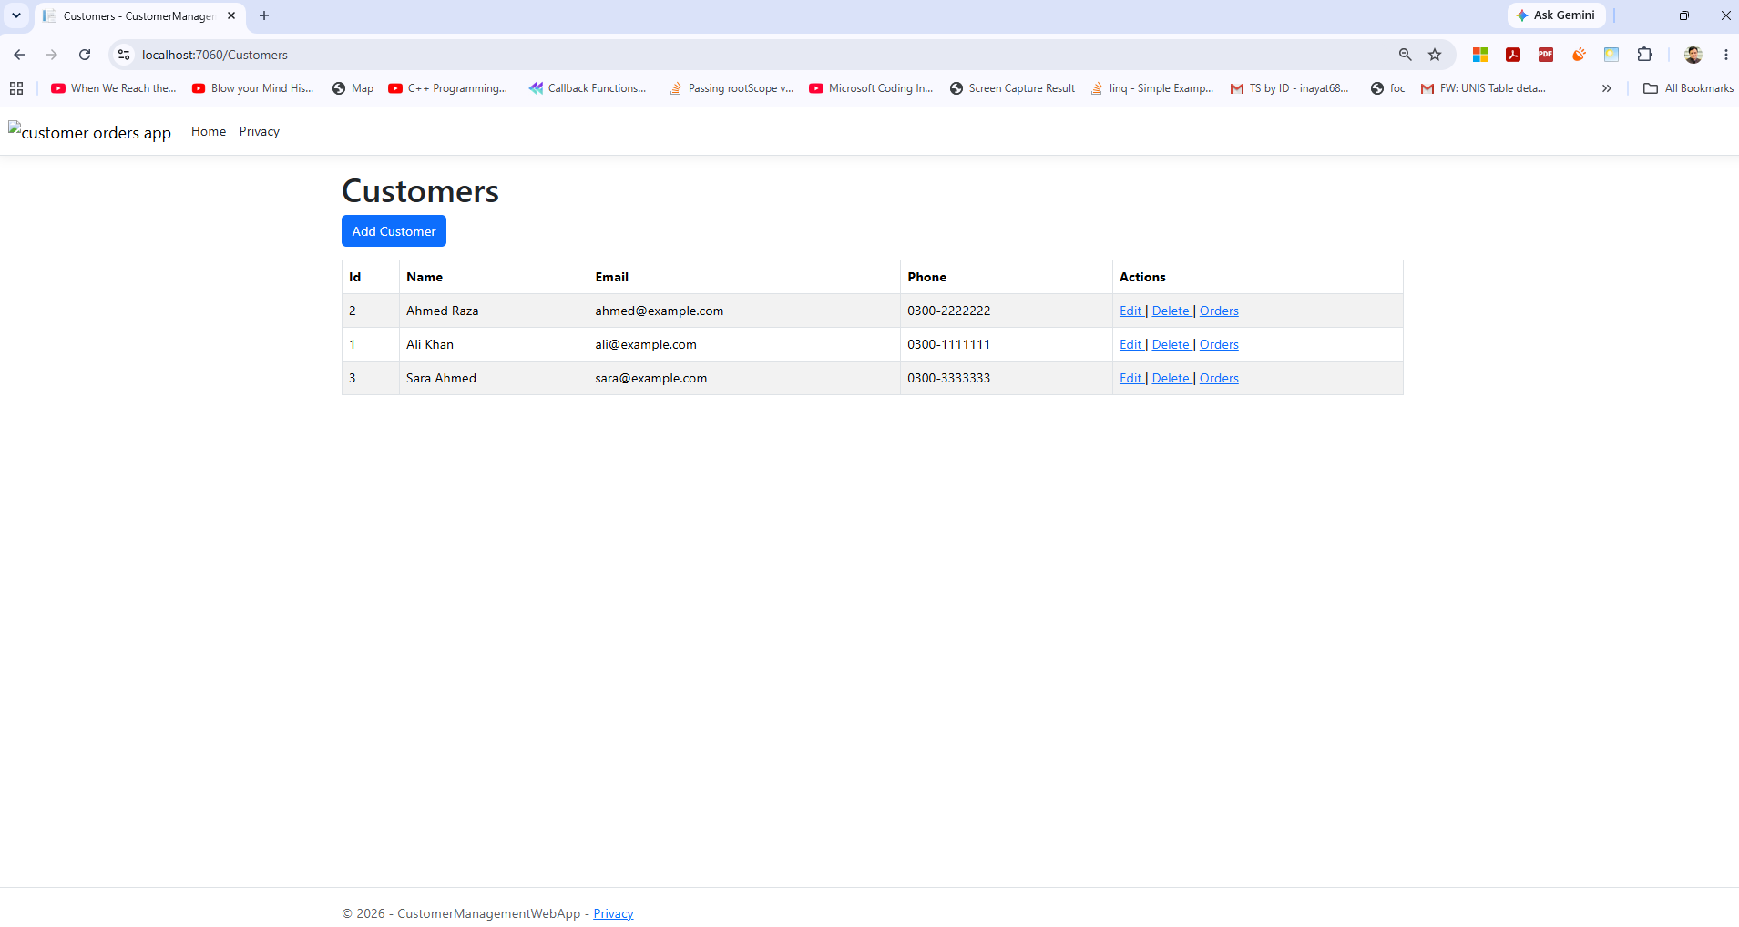

Order Page:
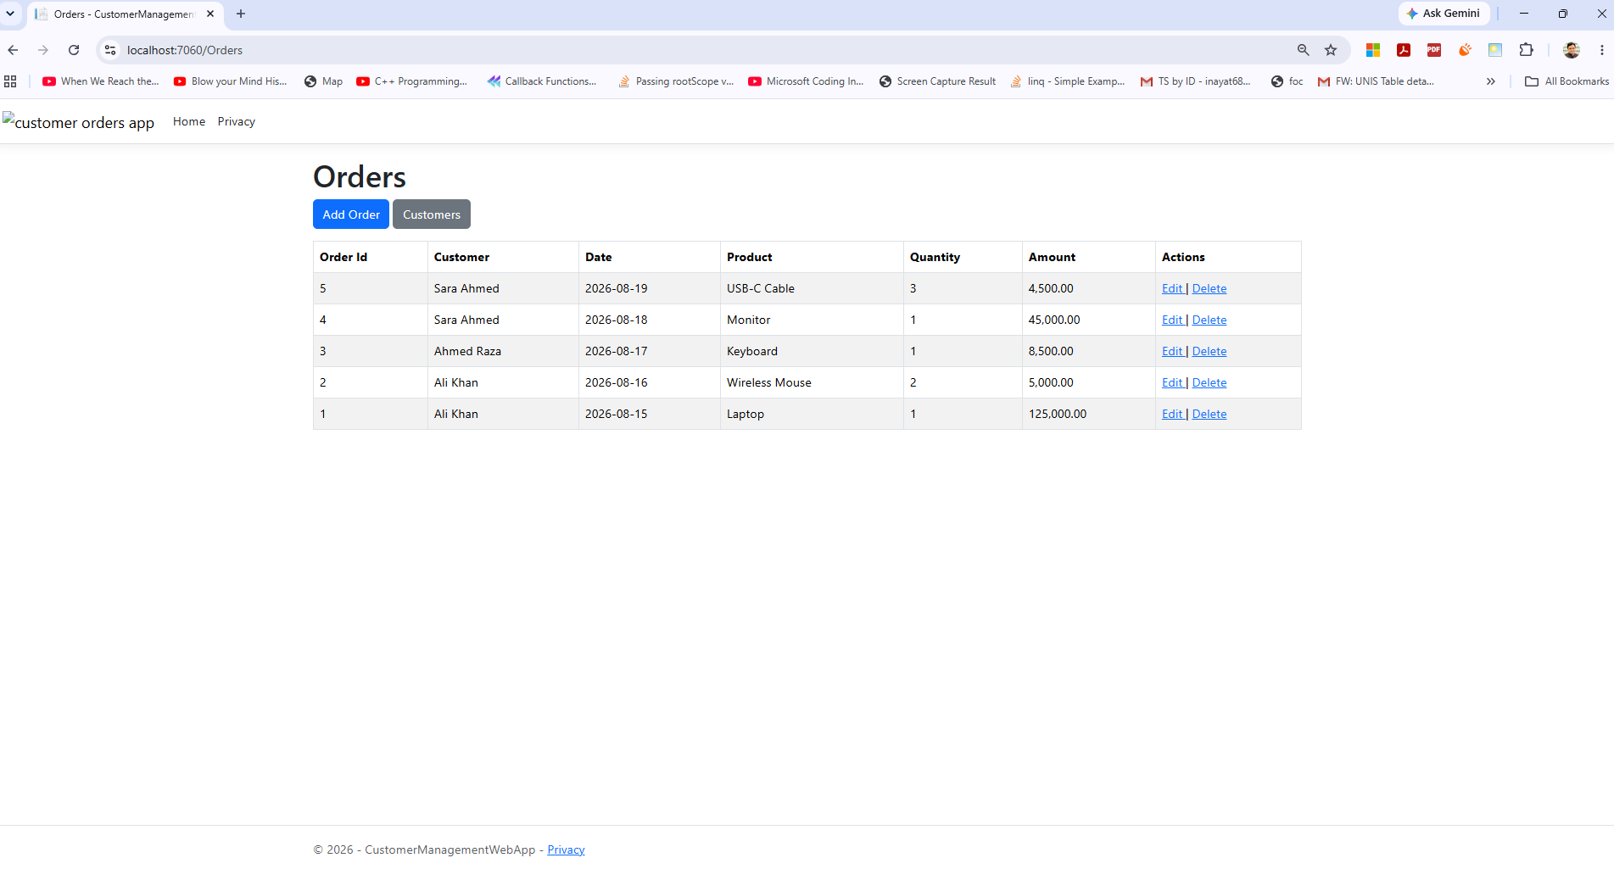

Appendix
1. Even no .NET Framework installed on a Windows PC, one can Publish the .NET project code and run it:
dotnet publish -c Release --self-contained true
- Self-contained Command: This command builds and publishes a .NET application as a self-contained application, meaning the target machine does not need to have the .NET Runtime installed.
2. Basics of .NET - Learning Material
https://csharp-video-tutorials.blogspot.com/p/free-c-video-tutorial-for-beginners.html

